FROBRILIGHT

JM300 PRO
Using Menual
V1.0.0

Typical Application Diagram

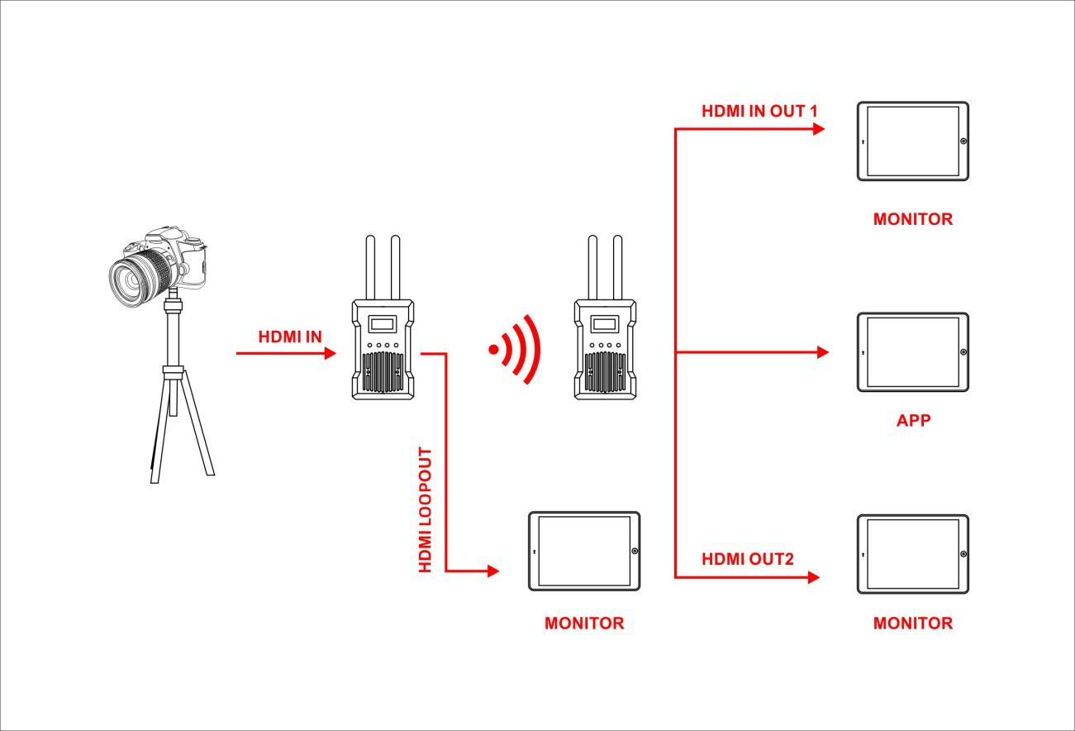
Port Definition

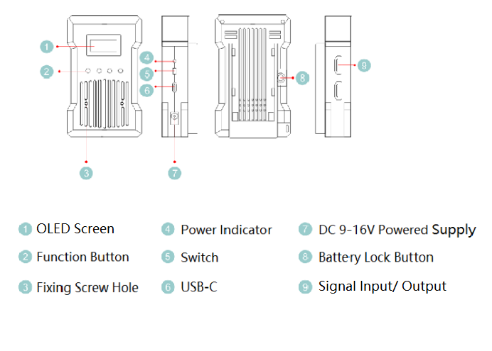

Installation and Use
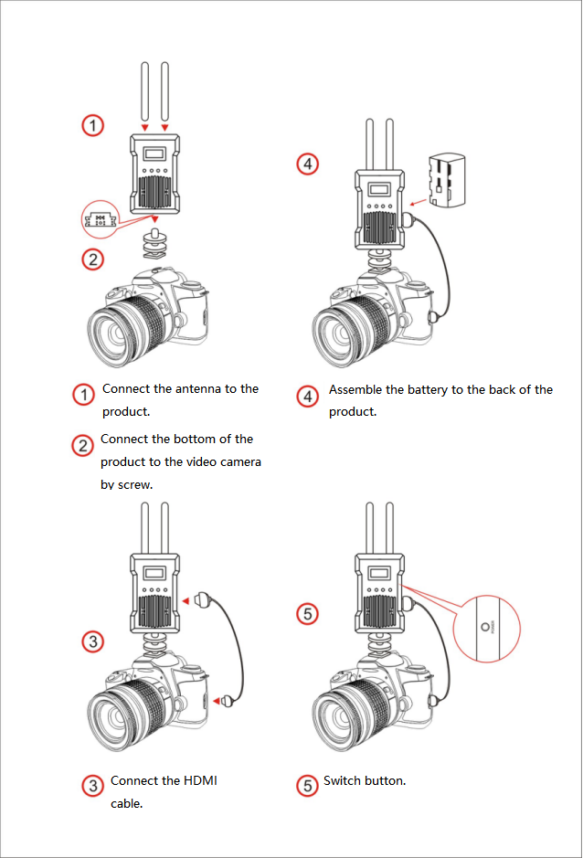

Operating Guidance

- Matching
- Press and hold the "Back button" of both transmitter and receiver at the same time for 5 seconds, then release them and they will matching automatically.
- Frequency Point Switch
- Press and hold the "Left and right keys" of the transmitter for 5 seconds and release it. After releasing it, it will automatically enter the frequency point switching menu. Press the left and right keys to switch between different frequency points.
- Other Menu
- Press and hold the “Enter key ”of the transmitter or the receiver for 5seconds and then release it, it will enter into other menu. You can check the name of the hotspot, version information and so on.

Technical Support
Any problem while your useing, please contact us at +86 13392199271, or email us at support@liangtu-tech.com.
Web: www.liangtu-tech.com
WhatsApp: +86 133 9219 9271

